GAES COMPILER

1. Install PIP in command prompt

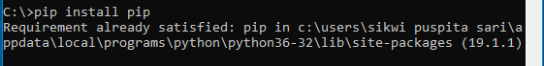

1. Install LLVMLITE

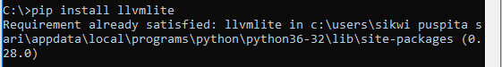

1. Install RPLY

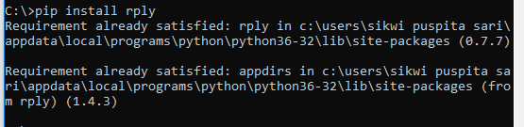

1. Install LLC

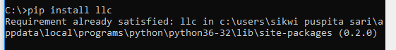

1. Mendefinisikan token di kelas lexer.py

